HEADLINE: #NeedThat: Student Photographer Christian Tolliver Creatively Captures Ole Miss

BYLINE: Chrishona Stanfield

TEASER: Looking for a photographer? Say less.

VISUAL: 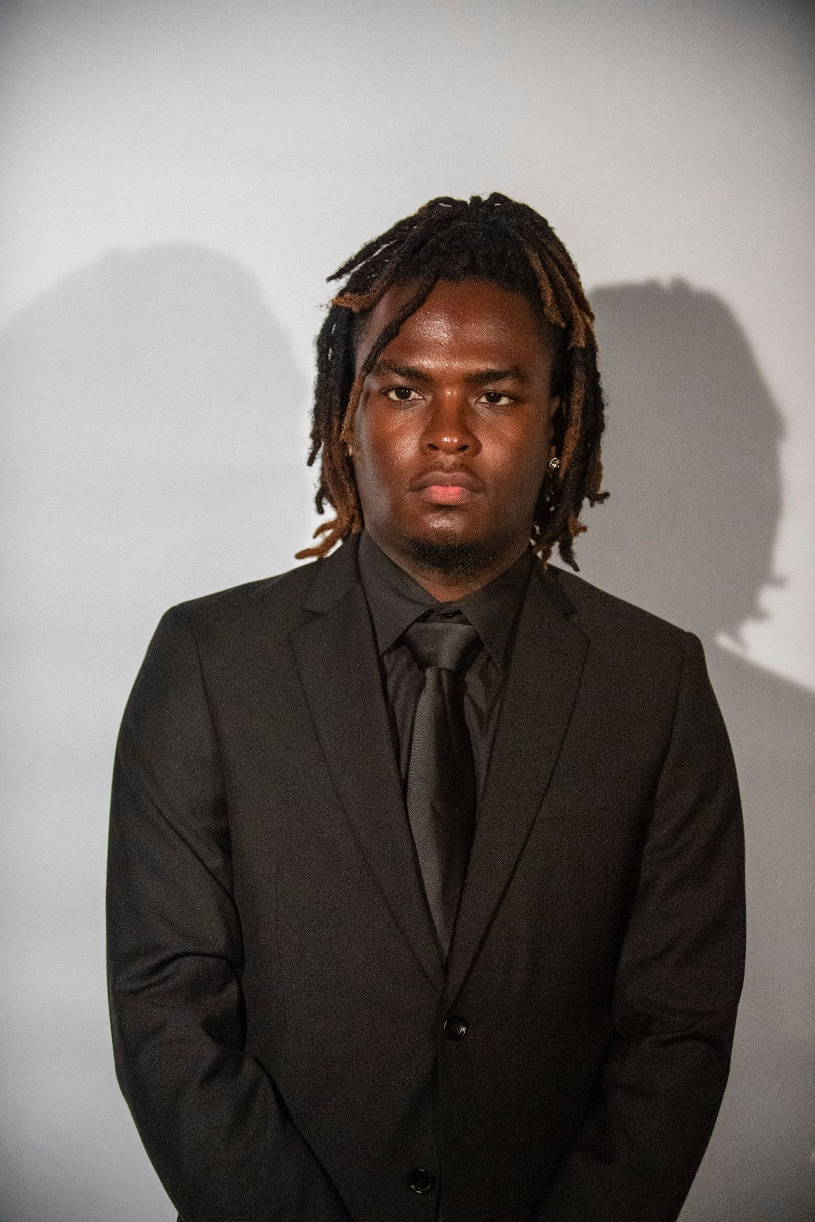

**Looking for a Photographer?**

Jackson, Mississippi, native and sophomore IMC major Christian Tolliver is the owner of ChrisCaptured1t. Inspired by exploring new ideas and helping clients fully express their individuality, Tolliver has made his mark at the University of Mississippi.

Specializing in sports photography, full photoshoots, headshots, and more, Tolliver prides himself on being a versatile photographer.

His rates are as follows:

* **$50 per hour** for singles and couples
* **$100 per hour** for organization shoots

For more information or to book a session, contact him on Instagram at [@ChrisCaptured1t](https://www.instagram.com/ChrisCaptured1t).